R
- R is a programming language.
- R is often used for statistical computing and graphical presentation to analyze and visualize data.

Why R?
- It is a great resource for data analysis, data visualization, data science and machine learning
- It provides many statistical techniques (such as statistical tests, classification, clustering and data reduction)
- It is easy to draw graphs in R, like pie charts, histograms, box plot, scatter plot, etc++
- It works on different platforms (Windows, Mac, Linux)
- It is open-source and free
- It has many packages (libraries of functions) that can be used to solve different problems
- R can be used for data transformation
- R is object oriented
- R objects are immutable and makes it more robust
- R is multi threaded and hence performance is not an issue with R
- R is distributed
- R is best suited for Unstructured data

R for Big Data:
While R is traditionally known for its performance on smaller datasets, it can also handle big data efficiently. Several R packages have been developed specifically for big data analytics, allowing users to process and analyze large datasets without compromising performance.

7. Use R-Project to carry out statistical analysis of big data

Sample Data: big_data.csv
Product_ID,Product_Category,Sales_Amount,Date
1,Electronics,150,2022-03-15
2,Clothing,80,2022-07-22
3,Books,120,2022-05-10
4,Home Decor,90,2022-08-05
5,Electronics,200,2022-01-28
6,Clothing,50,2022-11-14
7,Books,110,2022-09-19
8,Home Decor,70,2022-04-03
9,Electronics,180,2022-06-30
10,Clothing,70,2022-10-17

CSV Files:
- The full form of CSV is Comma-separated values.
- Comma-separated value is a simple yet powerful file format to store and exchange data.
- Values are separated using commas in this plain text file format.
- CSV files are often used to store data in a tabular format, such as spreadsheets or databases.
- These files are easy to create and edit, are compatible with a wide variety of software applications, and are easy to share and transfer.

Features of CSV files
- Delimiters: Delimiters are used to separate values in a row. The most
common delimiter is the comma but there are other delimiters such as tabs or semicolons.
- Quotes: Quotes make it possible to store any type of data in a CSV file.
- Header rows: Header rows help to identify the columns in the file

Applications of CSV files
CSV files are used in a variety of applications, including:
- Spreadsheets
- Databases
- Web applications
- Data science

How to use CSV files?
CSV files can be opened and edited with most spreadsheet applications, such as Microsoft Excel, Google Sheets, and LibreOffice. CSV can also be imported into other applications and databases.

Advantages of CSV files
- Simplicity: CSV files are plain text files and can be created and edited with
any text editor.
- Compatibility: CSV files are compatible with spreadsheet applications,
databases, and web applications.
- Portability: Sharing is easy as CSV files are plain text files.

Descriptive statistics :
- It is a branch of statistics aiming at summarizing, describing and presenting a series of values or a dataset.
- Long series of values without any preparation or without any summary measures are often not informative due to the difficulty of recognizing any pattern in the data. Below an example with the height (in cm) of a population of 100 adults:
188.7, 169.4, 178.6, 181.3, 179, 173.9, 190.1, 174.1, 195.2, 174.4, 188, 197.9, 161.1, 172.2, 173.7, 181.4, 172.2, 148.4, 150.6, 188.2, 171.9, 157.2, 173.3, 187.1, 194, 170.7, 172.4, 157.4, 179.6, 168.6, 179.6, 182, 185.4, 168.9, 180, 157.8, 167.2 and 181.5
Facing this series, it is hard (not to say impossible) for anyone to understand the data and have a clear view of the size of these adults in a reasonable amount of time.
- Descriptive statistics is often the first step and an important part in any statistical analysis. It allows to check the quality of the data by detecting potential outliers (i.e., data points that appear to be separated from the rest of the data), collection or encoding errors. It also helps to “understand” the data and if well presented.
- There exists many measures to summarize a dataset. They are divided into two types:
- Location Measures: Location measures give an understanding about the
central tendency of the data
- Dispersion Measures: dispersion measures give an understanding about the
spread of the data

Program:
# installing packages
install.packages("dplyr")
# dplyr − This package provides a grammar of data manipulation, allowing users to perform various operations like filtering, summarizing, and joining datasets efficiently.
install.packages("ggplot2")
# ggplot2 − ggplot2 is a highly flexible and powerful package for creating elegant and customizable data visualizations. It follows the grammar of graphics principles, allowing users to build complex plots layer by layer.
install.packages("pastecs")
# Package for Analysis of Space-Time Ecological Series

# Load required libraries
library(dplyr)
library(ggplot2)
library(pastecs)

# Read the big data from CSV file
big_data <- read.csv("D:/data.csv")
# load sample dataset and renamed it big_data

# View the structure of the dataset
str(big_data)
#Output:
'data.frame': 10 obs. of 4 variables:
$ Product_ID : int 1 2 3 4 5 6 7 8 9 10
$ Product_Category: chr "Electronics" "Clothing" "Books" "Home Decor" ...
$ Sales_Amount : int 150 80 120 90 200 50 110 70 180 70
$ Date : chr "2022-03-15" "2022-07-22" "2022-05-10" "2022-08-05" ...

# The dataset contains 10 observations and 4 variables, representing the
Product_ID, Sales_Amount as integers and Product_Category and Date as characters

# Data types in R:
- Numeric 2. Integer 3. Complex 4. Character 5.Factor 6.Logical

Numeric: A variable or a series will be stored as numeric data if the values are
numbers or if the values contains decimals. For example, the following two series are stored as numeric by default:

# numeric series without decimals
num_data <- c(3, 7, 2)
num_data
## [1] 3 7 2
class(num_data) #it displays the data type class
## [1] "numeric"

# numeric series with decimals
num_data_dec <- c(3.4, 7.1, 2.9)
num_data_dec
## [1] 3.4 7.1 2.9
# also possible to check the class thanks to str()
str(num_data_dec)
## num [1:3] 3.4 7.1 2.9
In other words, if you assign one or several numbers to an object in R, it will be stored as numeric by default (numbers with decimals), unless specified otherwise.

Integer: Integer data type is actually a special case of numeric data.
Integers are numeric data without decimals.
It can be used if you are sure that the numbers you store will never
contains decimals.
children
## [1] 1 3 2 2 4 4 1 1 1 4
children <- as.integer(children)
# Note that if your variable does not have decimals, R will automatically set the type as integers instead of numeric.

Complex: A complex value in R is defined via the pure imaginary value i. z = 1 + 2i # create a complex number
z # print the value of z
##[1] 1+2i
Character: Store text, known as strings in R.
char <- "some text"
char
## [1] "some text"
If you want to force any kind of data to be stored as character, you can do it by using the command as.character():
char2 <- as.character(children)
char2
## [1] "1" "3" "2" "2" "4" "4" "1" "1" "1" "4"
# Note that everything inside "" will be considered as character, no matter if it looks like character or not. For example:
chars <- c("7.42")
chars
## [1] "7.42"
Furthermore, as soon as there is at least one character value inside a variable or vector, the whole variable or vector will be considered as character:
char_num <- c("text", 1, 3.72, 4)
char_num
## [1] "text" "1" "3.72" "4"
Although space does not matter in numeric data, it does matter for character data:
num_space <- c(1)
num_nospace <- c(1)
# is num_space equal to num_nospace?
num_space == num_nospace
## [1] TRUE
char_space <- "text"
char_nospace <- "text"
# is char_space equal to char_nospace?
char_space == char_nospace
## [1] TRUE

char_space <- "text"
char_nospace <- "text "
# is char_space equal to char_nospace?
char_space == char_nospace
## [1] FALSE
As you can see from the results above, a space within character data (i.e., within "") makes it a different string in R!

Factor: Factor variables are a special case of character variables in the sense that it also contains text. However, factor variables are used when there are a limited number of unique character strings. It often represents a categorical variable. (qualitative variables (also referred as categorical variables or factors in R) are variables that are not numerical and which values fit into categories..
For instance, the gender will usually take on only two values, “female” or “male” (and will be considered as a factor variable) whereas the name will generally have lots of possibilities (and thus will be considered as a character variable). To create a factor variable use the factor() function:
gender <- factor(c("female", "female", "male", "female", "male"))
gender
## [1] female female male female male
## Levels: female male
To know the different levels of a factor variable, use levels():
levels(gender)
## [1] "female" "male"
By default, the levels are sorted alphabetically. You can reorder the levels with the argument levels in the factor() function:
gender <- factor(gender, levels = c("male", "female"))
levels(gender)
## [1] "male" "female"
Character strings can be converted to factors with as.factor():
text <- c("test1", "test2", "test1", "test1")
# create a character vector
text_factor <- as.factor(text) # transform to factor
The character strings have been transformed to factors, as shown by its class of the type factor.

Logical: A logical variable is a variable with only two values; TRUE or FALSE:
value1 <- 7
value2 <- 9
# is value1 greater than value2?
greater <- value1 > value2
greater
## [1] FALSE
# is value1 less than or equal to value2?
less <- value1 <= value2
less
## [1] TRUE
It is also possible to transform logical data into numeric data. After the transformation from logical to numeric with the as.numeric() command, FALSE values equal to 0 and TRUE values equal to 1:
greater_num <- as.numeric(greater)
sum(greater)
## [1] 0
less_num <- as.numeric(less)
sum(less)
## [1] 1
Conversely, numeric data can be converted to logical data, with FALSE for all values equal to 0 and TRUE for all other values.
x <- 0
as.logical(x)
## [1] FALSE
y <- 5
as.logical(y)
## [1] TRUE

# Summary statistics
summary(big_data)
#Output:
Product_ID Product_Category Sales_Amount Date
Min. : 1.00 Length:10 Min. : 50.0 Length:10
1st Qu.: 3.25 Class :character 1st Qu.: 72.5 Class :character
Median : 5.50 Mode :character Median :100.0 Mode :character
Mean : 5.50 Mean :112.0
3rd Qu.: 7.75 3rd Qu.:142.5
Max. :10.00 Max. :200.0
# You can compute the minimum, 1st quartile, median, mean, 3rd quartile and the maximum for all numeric variables of a dataset at once using summary()
# Quantiles are points in a distribution that relate to the rank order of values in that distribution.
# For a sample, you can find any quantile by sorting the sample. The middle value of the sorted sample (middle quantile, 50th percentile) is known as the median. The limits are the minimum and maximum values. Any other locations between these points can be described in terms of centiles/percentiles.
# Centiles/percentiles are descriptions of quantiles relative to 100; so the 75th percentile (upper quartile) is 75% or three quarters of the way up an ascending list of sorted values of a sample. The 25th percentile (lower quartile) is one quarter of the way up this rank order.

# Percentile rank is the proportion of values in a distribution that a particular value is greater than or equal to. For example, if a pupil is taller than or as tall as 79% of his classmates then the percentile rank of his height is 79, i.e. he is in the 79th percentile of heights in his class.

#any quantile can also be computed with the quantile() function. For instance, the 4th decile:

quantile(big_data$Sales_Amount, 0.4) # 4th decile
#Output:
40%
86

stat.desc(big_data) # given in library(pastecs)
#Output:
Product_ID Product_Category Sales_Amount Date
nbr.val 10.0000000 NA 10.0000000 NA
nbr.null 0.0000000 NA 0.0000000 NA
nbr.na 0.0000000 NA 0.0000000 NA
min 1.0000000 NA 50.0000000 NA
max 10.0000000 NA 200.0000000 NA
range 9.0000000 NA 150.0000000 NA
sum 55.0000000 NA 1120.0000000 NA
median 5.5000000 NA 100.0000000 NA
mean 5.5000000 NA 112.0000000 NA
SE.mean 0.9574271 NA 15.9024806 NA
CI.mean.0.95 2.1658506 NA 35.9739104 NA
var 9.1666667 NA 2528.8888889 NA
std.dev 3.0276504 NA 50.2880591 NA
coef.var 0.5504819 NA 0.4490005 NA
# create a table that contains descriptive statistics for variables in a data frame in R.
# One of the best ways is by using the stat.desc() function from the pastecs package
in R, which can be used to perform this exact task.
The stat.desc() function uses the following syntax:
stat.desc(x, basic=TRUE, desc=TRUE, norm=FALSE, p=0.95)
where:
- x: Name of data frame
- basic: Whether to return basic statistics or not
- desc: Whether to return more advanced statistics or not
- norm: Whether to return normal distribution statistics or not
- p: The p-value to use when calculating confidence interval values
# The stat.desc() function returns a table of descriptive statistics for each of the
columns in the data frame.

# Notice that each of the values in the team Product_Category and Date columns are
shown as NA since we are not able to calculate numerical descriptive statistics for a column that only contains character values.

# Instead, we may choose to use the following syntax to only calculate the
descriptive statistics for the Product_ID and Sales_Amount in the data frame:
stat.desc(big_data[c('Product_ID', 'Sales_Amount')])
#Output:
Product_ID Sales_Amount
nbr.val 10.0000000 10.0000000
nbr.null 0.0000000 0.0000000
nbr.na 0.0000000 0.0000000
min 1.0000000 50.0000000
max 10.0000000 200.0000000
range 9.0000000 150.0000000
sum 55.0000000 1120.0000000
median 5.5000000 100.0000000
mean 5.5000000 112.0000000
SE.mean 0.9574271 15.9024806
CI.mean.0.95 2.1658506 35.9739104
var 9.1666667 2528.8888889
std.dev 3.0276504 50.2880591
coef.var 0.5504819 0.4490005

Here is how to interpret each value in the output:
- nbr.val: Number of values
- nbr.null: Number of null values
- nbr.na: Number of NA values
- min: Minimum value
- max: Maximum value
- range: Range (max – min) of values
- sum: Sum of values
- median: Median value
- mean: Mean value
- S.E. mean: Standard error of mean value
- CI mean .95: 95% confidence interval for mean value
- var: Variance of values
- std.dev: Standard deviation of values
- coef.var: Coefficient of variation of values

# Perform some data manipulation (e.g., filtering, grouping, summarizing)
# Example: Calculate total sales by product category
total_sales <- big_data %>%
group_by(Product_Category) %>%
summarise(Total_Sales = sum(Sales_Amount))

# View the resulting data frame
total_sales
# Output:
A tibble: 4 × 2
Product_Category Total_Sales
<chr> <int>
1 Books 230
2 Clothing 200
3 Electronics 530
4 Home Decor 160

# Bar Plot
# Visualize the total sales by product category using a bar plot
# Barplots can only be done on qualitative variables. A barplot is a tool to
visualize the distribution of a qualitative variable. We draw a barplot of the qualitative variable total_sales and product category:

ggplot(total_sales, aes(x = Product_Category, y = Total_Sales)) +
geom_bar(stat = "identity", fill = "skyblue") +
labs(title = "Total Sales by Product Category",
x = "Product Category",
y = "Total Sales") +
theme_minimal()
#Output: 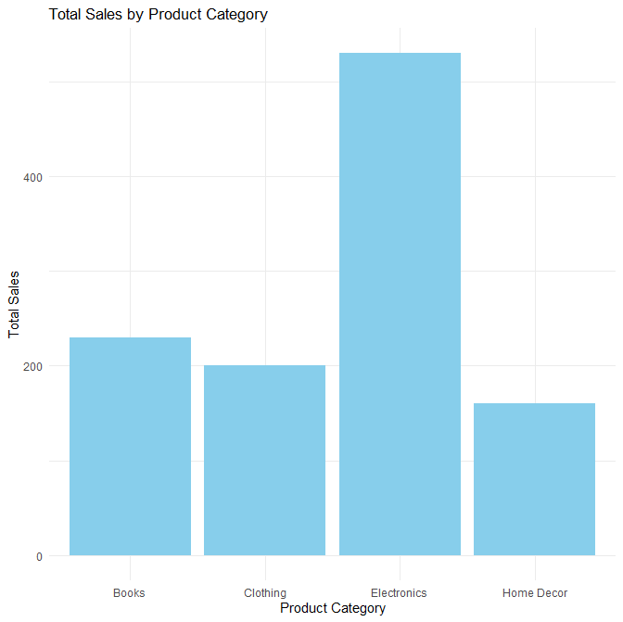

# Histogram: A histogram gives an idea about the distribution of a quantitative
variable. The idea is to break the range of values into intervals and count how many observations fall into each interval. Histograms are a bit similar to barplots, but histograms are used for quantitative variables whereas barplots are used for qualitative variables.
ggplot(big_data) +
aes(x = Sales_Amount) +
geom_histogram()
#Output
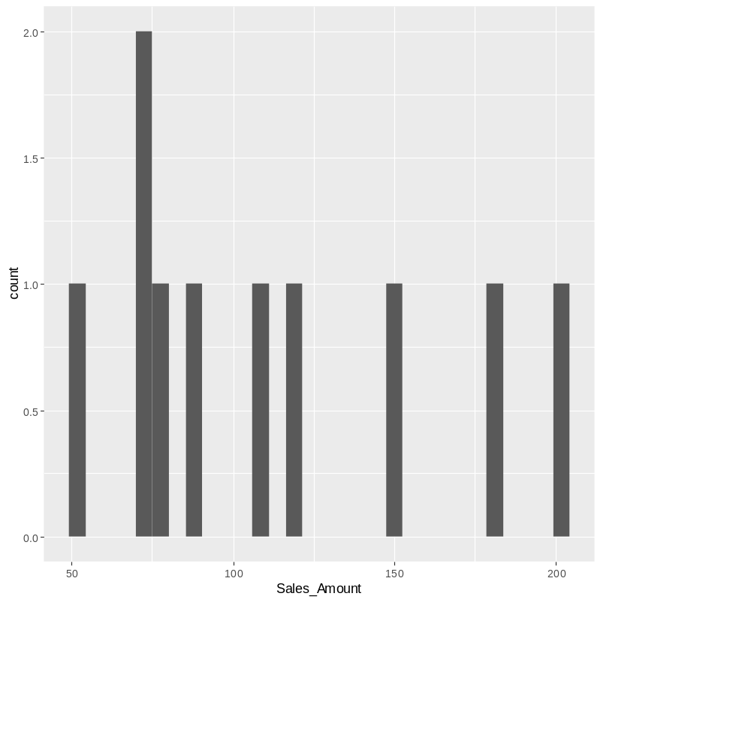
By default, the number of bins is 30. You can change this value with geom_histogram(bins = 12)

# Quantitative: A quantitative variable is a variable that reflects a notion
of magnitude, that is, if the values it can take are numbers. A quantitative variable represents thus a measure and is numerical.
Quantitative variables are divided into two types: discrete and continuous.
# Discrete: Quantitative discrete variables are variables for which the values it can
take are countable and have a finite number of possibilities. The values are often (but not always) integers. some examples of discrete variables:
- Number of children per family
- Number of students in a class
- Number of citizens of a country
Whatever the number of children in a family, it will never be 3.58 or 7.912 so the number of possibilities is a finite number and thus countable.
# Continuous: Quantitative continuous variables are variables for which the values
are not countable and have an infinite number of possibilities. For example:
- Age
- Weight
- Height
For simplicity, we usually referred to years, kilograms (or pounds) and centimeters (or feet and inches) for age, weight and height respectively. However, a 28-year-old man could actually be 28 years, 7 months, 16 days, 3 hours, 4 minutes, 5 seconds, 31 milliseconds, 9 nanoseconds old.
# Qualitative
In opposition to quantitative variables, Qualitative variables (also referred as categorical variables or factors in R) are variables that are not numerical and which values fit into categories.
Qualitative variables are divided into two types: nominal and ordinal.
# Nominal: A qualitative nominal variable is a qualitative variable where no
ordering is possible or implied in the levels.
For example, the variable gender is nominal because there is no order in the levels (no matter how many levels you consider for the gender—only two with female/male, or more than two with female/male/ungendered/others, levels are unordered).
A nominal variable can have:
- two levels (e.g., do you smoke? Yes/No, or are you pregnant? Yes/No), Note that a qualitative variable with exactly 2 levels is also referred as a binary or dichotomous variable.
# Ordinal: A qualitative ordinal variable is a qualitative variable with an order
implied in the levels. For instance, if the severity of road accidents has been measured on a scale such as light, moderate and fatal accidents, this variable is a qualitative ordinal variable because there is a clear order in the levels.

# Correlation
# Another descriptive statistics is the correlation coefficient. The correlation measures the linear relationship between two variables, and it can be computed with the cor() function:
cor(big_data$Product_ID, big_data$Sales_Amount)
# Output:
[1] -0.1313589

# Contingency table
big_data$size <-ifelse(big_data$Sales_Amount<median(big_data$Sales_Amount),
"small", "big")
table(big_data$size)
# Output:
big small
5 5
# The contingency table gives the number of cases in each subgroup.
The variable size is created for Sales_Amount less than the median of
Sales_ Amount that is there are 5 small and 5 big amounts.

big_data$size <-ifelse(big_data$Sales_Amount<median(big_data$Sales_Amount),
"small", "big")
table(big_data$Product_Category, big_data$size)
# Output:
big small
Books 2 0
Clothing 0 3
Electronics 3 0
Home Decor 0 2

#We now create a contingency table of the two variables Product_Category and Sales_Amount with the table() function:
table(big_data$Product_Category, big_data$Sales_Amount)

50 70 80 90 110 120 150 180 200
Books 0 0 0 0 1 1 0 0 0
Clothing 1 1 1 0 0 0 0 0 0
Electronics 0 0 0 0 0 0 1 1 1
Home Decor 0 1 0 1 0 0 0 0 0

